Setting Up a DerbyNet Server on a Mac
DerbyNet depends on a web server platform with PHP and access to a database. This document describes options for setting up these underlying technologies on a Mac.
Mac OS X comes with Apache web server and PHP pre-installed, but both are deactivated by default (in 10.9 Mavericks and 10.10 Yosemite). Activating the necessary pieces is a relatively simple process.
A Mac installation of DerbyNet can support either a MySQL database or an SQLite database. While MySQL is the more traditional database choice, SQLite is already installed in Mac OSX. (Curious readers should see http://www.sqlite.org/whentouse.html for some additional discussion.)
This document describes two options for setting up a web server/PHP/database stack:
- Activate and configure the software already present in Mac OS X; or
- Install a separate stack by downloading a MAMP installer.
(Of course, there are other options available, but they're outside the scope of this document.)

Option 1: Activate and Configure Existing Software

Activate Apache Server (Web Sharing)

Using System Preferences Plug-In
The easiest way to do this is to download a nice System Preferences plug-in from http://clickontyler.com/web-sharing/ that lets you turn the Apache web server ("web sharing") on and off.

Using the Command Line
It's also possible to activate the web server just from the command line (the “Terminal” application), without installing any additional software. The command is:
sudo apachectl start
The command to stop the server is:
sudo apachectl stop

Confirm Activation
If you've started the web server, you should be able to open a browser to http://localhost and see an “It works!” page appear.

Recommended: Rotate Logs
See http://linuxdev.dk/blog/log-rotation-mac
/etc/newsyslog.d/apache2.conf

Activate PHP
To activate PHP for the Apache web server, it's necessary to make two small changes in the Apache configuration file. Follow the instructions available at http://php.net/manual/en/install.macosx.bundled.php for details.
Important: Be sure to restart the Apache web server after editing the configuration file.

Install Web Site

Installing as Root
If you want to serve DerbyNet as the only thing on this web server (i.e., if you don't have any other web content being served from this Mac) you would enter this command in the Terminal:
sudo mv -R website/* /Library/WebServer/Documents/
and confirm that it worked by opening a browser and pointing it to http://localhost.
[ For the remainder of these instructions, we'll assume that you installed DerbyNet at root level, as above. Modify commands as appropriate if, instead, you installed in a subdirectory. ]

Create a Local Subdirectory
Create a "local" subdirectory if one doesn't already exist, and make sure it's writable by the _www user, e.g.,
sudo mkdir /Library/WebServer/Documents/local
sudo chmod 777 /Library/WebServer/Documents/local

Congratulations!
You've finished the hard part.

Option 2: Install Separate MAMP Stack

Download and Install Bitnami Stack
Bitnami provides a free, convenient, MAMP (Mac, Apache, MySQL, PHP) stack as a single-step install:
https://bitnami.com/stack/mamp
The Bitnami MAMP stack runs as a separate web server, listening on port 8080 instead of the usual HTTP port 80. It includes a full MySQL install, as well as phpMyAdmin, a web-based interface for creating and managing MySQL databases.
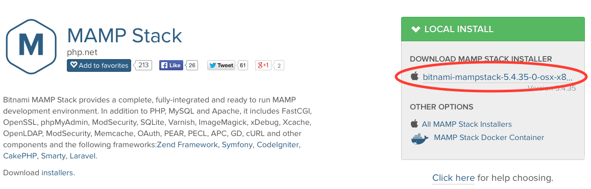
Note that it is NOT necessary to create a Bitnami account if you don't care to:
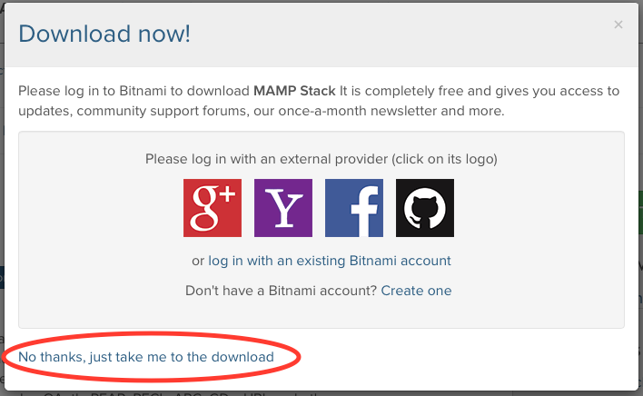

When you launch the installer, you'll be asked to confirm that you know you're running software that you downloaded:
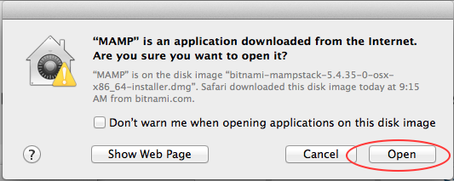

After that, follow the instructions in the installer. Choose the default options unless you have a particular reason to decide otherwise.

Install Web Site

Installing as Root
If you want to serve DerbyNet as the only thing on this web server (i.e., if you don't have any other web content being served from this Mac) you would enter this command in the Terminal:
sudo mv -R website/* /Applications/mampstack-5.4.35-0/apache2
and confirm that it worked by opening a browser and pointing it to http://localhost:8080.
[Obviously, the MAMP stack version number in the file path might be different in your installation if the installer has been upgraded. Modify commands as appropriate if, instead, you installed in a subdirectory.]

Create a Local Subdirectory
Create a "local" subdirectory if one doesn't already exist, and make sure it's writable by the _www user, e.g.,
sudo mkdir /Applications/mampstack-5.4.35-0/apache2/local
sudo chmod 777 /Applications/mampstack-5.4.35-0/apache2/local

Congratulations!
You've finished the hard part.

